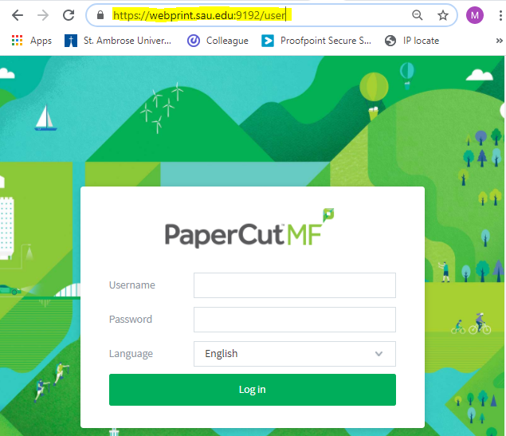
1 ) For printing from Web Print please first go to ‘https://webprint.sau.edu:9192/user’ to sign in

2) Then go to ‘Web Print’ and click ‘Submit a Job’ to create the job you want printed
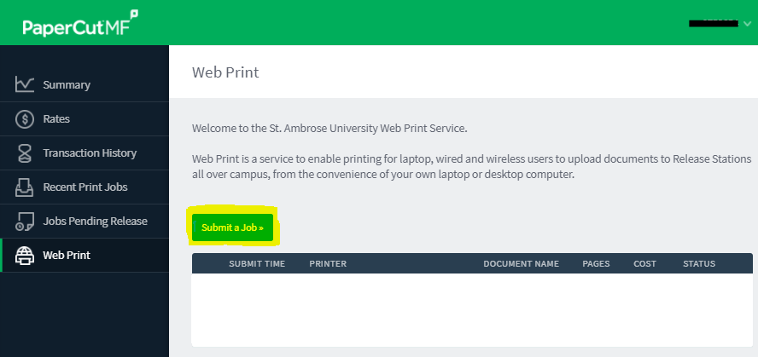

3) Select the printer you wish to print from. You can also use the quick search to type in the location and select the wanted printer. Then click ‘Print Options and Account Selection’ in the bottom right.
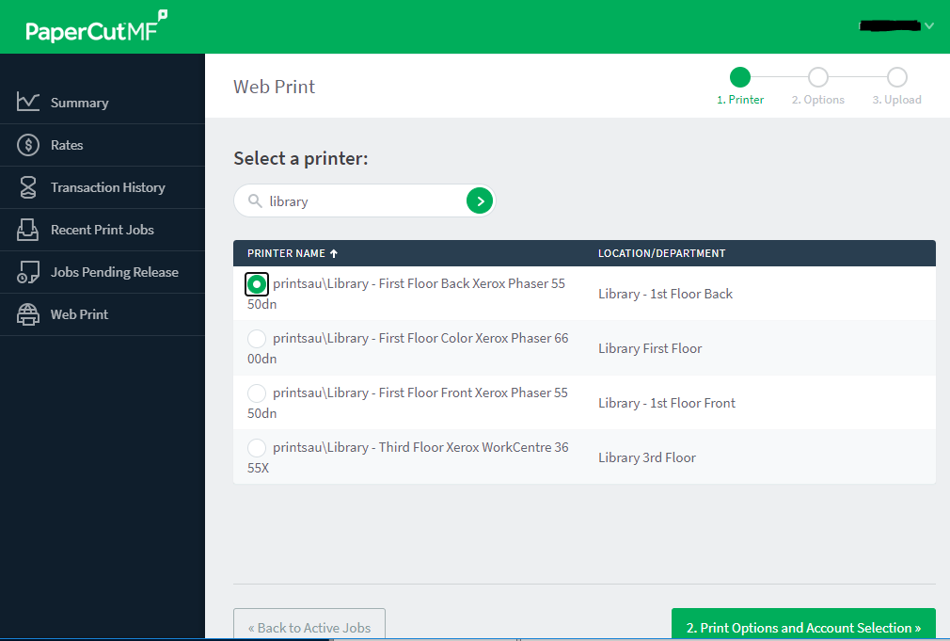

4) After selecting the number of copies requested, click ‘3. Upload Documents’ to proceed
- Web Print defaults to double-sided printing. There is NOT an option to print single sided pages through Web Print. The only way to print one sided is to either be at a computer lab on campus with a dedicated printer or to create a job for each individual page. There are instructions on how to print in the lab in another document labeled ‘One Sided Printing’.
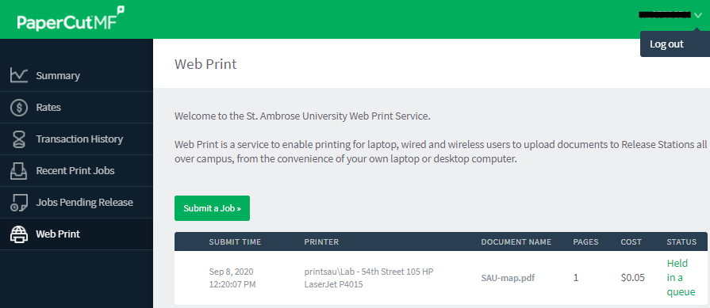
5) Upload or drag and drop the wanted document into the box provided. Then click ‘Upload & Complete’ to process the job. After the job is processed, you may have to logout before proceeding to https://papercut1.sau.edu:9192/mobile/release

6) Go to https://papercut1.sau.edu:9192/mobile/release and sign in to release the print job from Web Print.
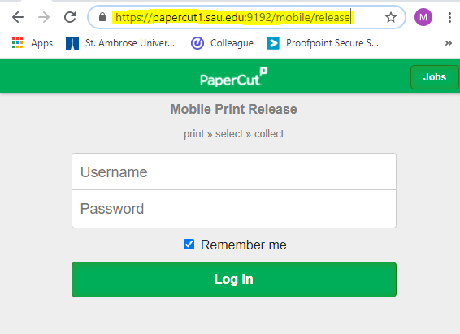

7) After logging in, the below page should be displayed. If this page does not come up, please log out, close the browser, reopen, and go directly to the https://papercut1.sau.edu:9192/mobile/release page.
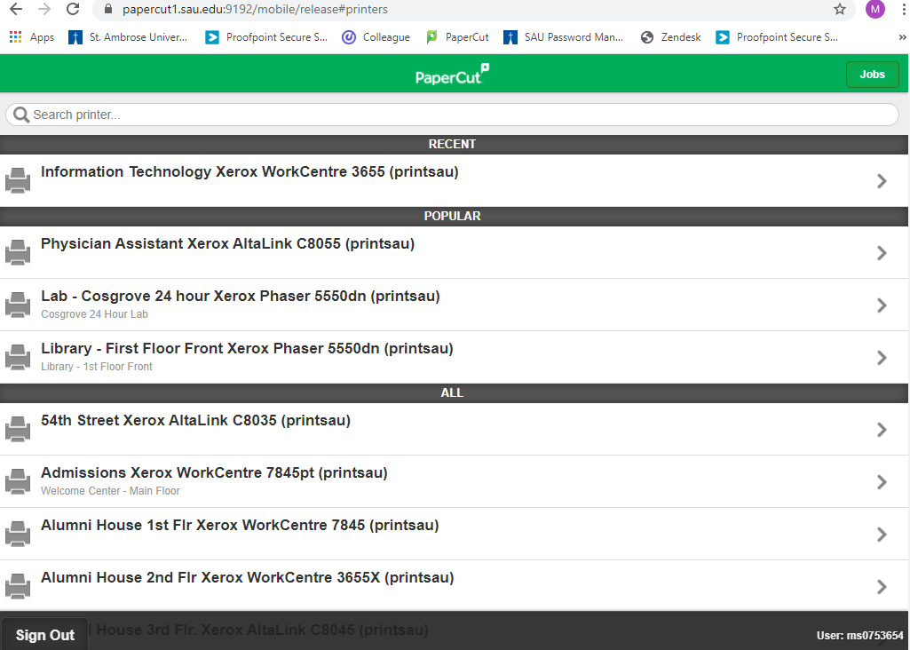

8) Select the printer the job was created for in Web Print. After selecting, you should be brought to the below screen.
Before clicking ‘Release’ make sure that you are in front of the printer that you will be printing from, that there is enough paper available to complete your job(s), and that there is not an error (processing, paper jam, toner, etc.) displayed. Once ready, click ‘release’ for one job at a time.
Please make sure that the printer processes and completes the job accurately before releasing jobs.
