To make a payment as a former student or authorized user, please go to SAU.edu
At the home page please click A-Z to bring up the directory
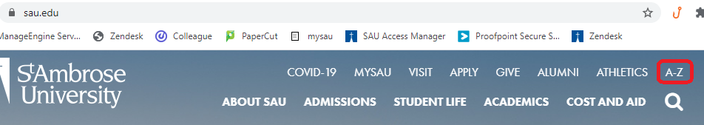
Click on the B or scroll down to find BeeCentral
At BeeCentral’s homepage, scroll down to ‘Click here to login to Student Billings as an Authorized User or Former Student’
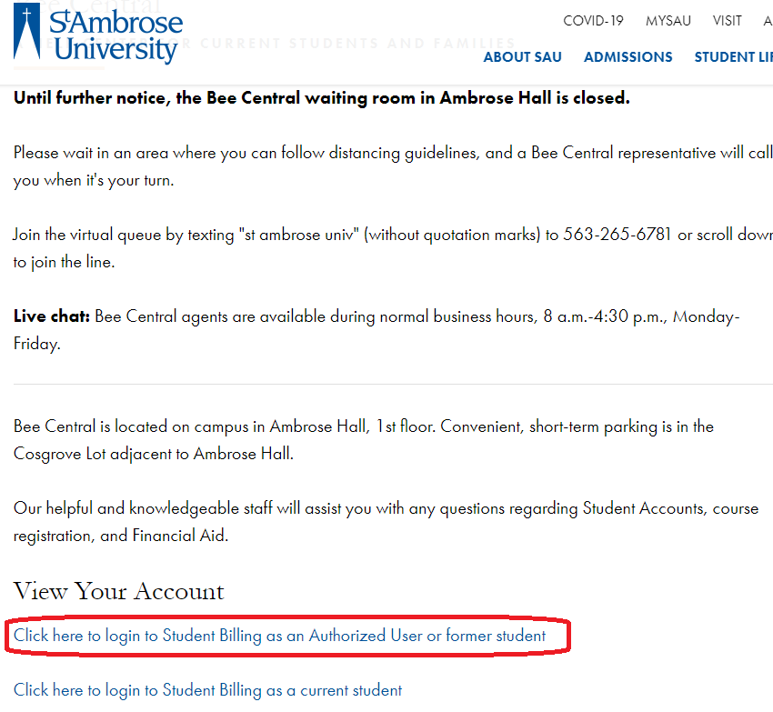

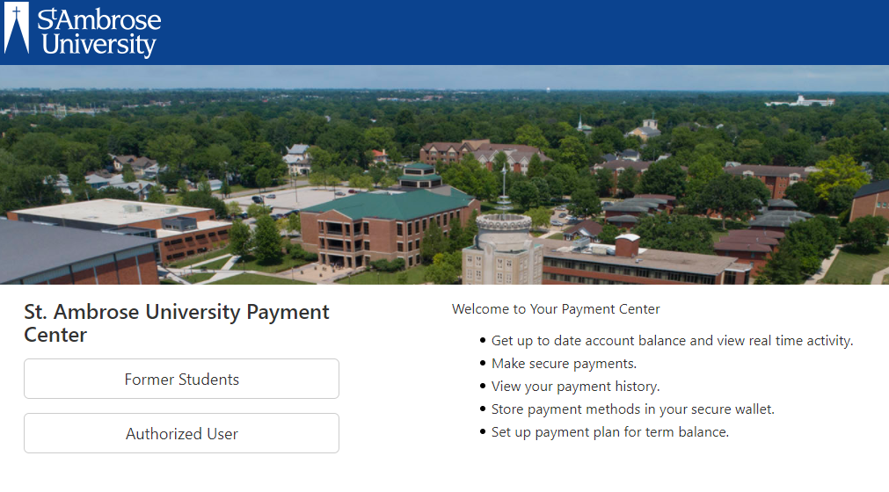

Please select if you are either a ‘Former Student’ or ‘Authorized User’
Former Students: the below message will prompt:
If you are a former student wishing to utilize our online payment system to pay an outstanding balance, please contact the Information Technology Help Desk to receive a PIN. 563-333-6368

Please call us or send a message to ITSupport@sau.edu with your student ID number to request the PIN.
A service provider may ask you additional questions to confirm your identification.

Authorized Users:
Please use the email that the student provided through their account settings as an authorized user. If the password is not known, please select ‘Forgot Password’. An email to reset the password will be sent to the provided email if the student has set the account as an authorized user.

