Go to Google.com and click your account avatar on the top right of the page.
Click ‘Manage your Google Account’
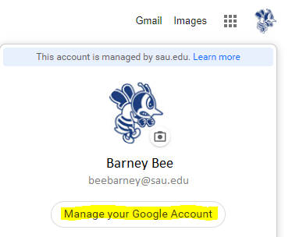

Select the ‘Security’ Tab at the top
Then scroll down to find ‘Signing in to Google’
You’ll be able to activate ‘2-Step Verification’ by clicking the button and going through the prompts.
You will need to re-sign in to verify your account access.
Then select or set up your phone.
A message will be sent to your phone like the one below:

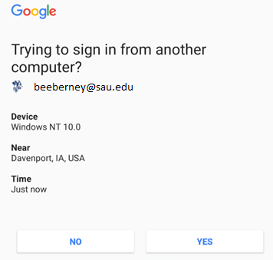

Click ‘Yes’ on the device and then the process will proceed.
When asked to provide a backup number the primary phone or another phone number may be used.
After this is submitted, it should allow you to activate 2-step.

