- Click on the Windows icon in the lower left taskbar corner
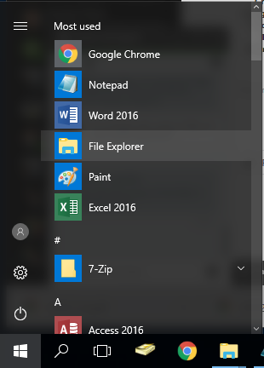
- Select ‘File Explorer’

- In File Explorer find ‘This PC’ and RIGHT click it to open a menu
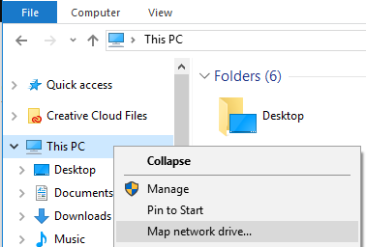
- Click ‘Map network drive…’ from the menu

- The below screen shown in step 7 should come up
- Select the Drive you wish to assign the network map to
- In the ‘Folder:’ field, type in the provided network path in the highlighted area below
Users should know the name of the shared drive they are attempting to connect to. Please do not use Drive: Z

If misspelled, using incorrect slashes, or using wrong shared drive name, the drive will not map

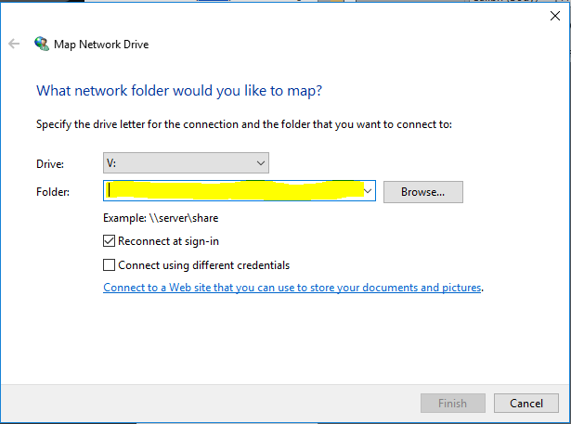

- Please make sure that 'Reconnect at sign-in' is checked
- Click ‘Finish’
- The mapped drive should now be located in your File Explorer

