- Sign into your Gmail account and click on the Gear icon in the upper right corner.
- The ‘Settings’ menu should display as below.
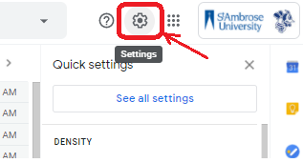

- Click on ‘See all settings’ to open fully open the settings menu
- Select the ‘Accounts’ tab below the ‘Settings’ title
- Click on ‘Add another email address’ and the window in step 6 should open

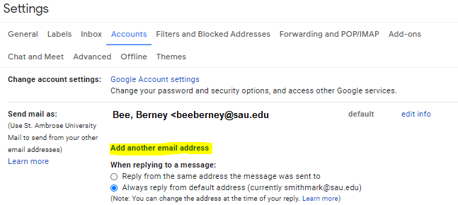

- In the ‘Name’ field, enter the name you’d like to show when others receive your mail. The ‘Email address’ is the email you want to send as. Please make sure to uncheck the ‘Treat as an alias’ box.
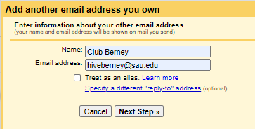

- Click ‘Next Step’
- Click ‘Send Verification’
- An email will be sent to account you’re requesting to send as. That account will be provided the confirmation code to be used and a confirmation link. Please enter the confirmation code in the below field and click ‘Verify’
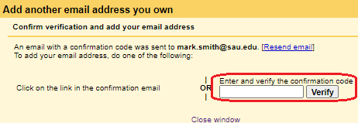

- Another email will be sent to the account with putting in the original request. Click on the confirmation link in the email and click ‘Confirm’. Google will then let you know what you can send as another account.

- To send as another account, compose a new email, click ‘Recipients’, then you’ll see ‘From’ displayed, next to the email name should be a down arrow. Click the arrow and selected the other account.
